07.05 -
Resource & Staff allocation
Process Design & AMOS Configuration Document
Purpose
This Process Design document is provided to Key-Users to record their key decisions regarding the AMOS Process design and the required AMOS configuration.
It is updated throughout the Project Definition Phase and used as the baseline for the Final Acceptance prior to Go-Live
Revision
Author, Name | Date | Notes
GAVG | 21.08.2024 | Initial Issue
FDEL | 13.01.25 | Rev.01

Table of Contents
1. Process Overview & Objectives 3
2. Regulatory References 3
3. Definitions & Glossary 3
4. Process Tasks 4
5. Process Dependencies 4
6. Process Flow 5
7. Process Design Questions 6
8. Data (Source) Mapping 7
9. Other Software Used 7
10. AMOS Configuration 8
a. Basic Data 8
b. Parameters 8
c. Workflows 8
d. Scheduled Tasks 8
e. API’s & Interfaces 9
11. Annex – Additional Info 9

Process Overview & Objectives

Process General Description:
The Resource & Staff allocation process focuses on answering the requests for resources that arise from operations. The process covers resources (Tools, Equipment and Facilities) and staff. Based on the requests of planned maintenance activities, this process assigns requested resources whilst keeping in mind the available capacity, timelines and other conditions.
Main Process Objective (Outputs & Outcomes) :
- Answering the resource requests of operations for:
  - Staff
  - Tools & Equipment
  - Facilities
- Re- / De- / Assigning resources for operations to optimize utilization.
- Providing feedback based on capacity vs request.

Regulatory References

The following regulatory references are linked to this business process:
- EASA Part-145 145.A.25 – Facility requirements
- EASA Part-145 145.A.30 – Personnel requirements
- EASA Part-145 145.A.35 – Certifying staff and support staff
- EASA Part-145 145.A.37 – Airworthiness review staff
- EASA Part-145 145.A.40 – Equipment and tools
- EASA Part-145 145.A.47 – Production Planning

Definitions & Glossary

Key-Words | Explanation
Resource Requests | Resource request is the generic term for any request for either Tools, Equipment or Facilities.
Staff Requests | A staff request is the term used for a request for a specific type of qualified staff.
Capacity | The capacity is the availability over time of the various resources and staff.
Workload | Workload is the maintenance activity in the form of a workpackage or individual event, often expressed in manhours. From a workload, resource & staff requests arise.
Reservation | Once a resource has been assigned to a maintenance event, it is considered reserved.

Process Tasks

Business Process Task / Actions / Activities:
- Managing available resource capacity based on requests/workload: When assigning/de-assigning resources in e.g. APN2323, AMOS automatically calculates the remaining capacity of the relevant resource or staff. This allows the resource planner to keep close control of the remaining capacity. Make sure to activate the Capacity View whenever available. Green capacity indicates a positive availability, whereas red capacity shows a shortage.
- Assigning/De-assigning staff to maintenance events based on their qualifications and availability: An important element when planning staff, is to make sure the right staff is assigned at the right time. Having a solid qualification structure of your staff and assigning the closest possible qualified staff to the task, allows you to spread staff capacity by qualification. Always consider the criticality of the requesting maintenance event. APNs for resource & staff allocation have the possibility to filter for different resources, fleet, workpackages and other relevant criteria.
- Assigning/De-assigning Tools & Equipment based on availability: Always consider the criticality of the requesting maintenance event. APNs for resource & staff allocation have the possibility to filter for different resources, fleet, workpackages and other relevant criteria.
- Assigning/De-assigning Facilities based on availability: Always consider the criticality of the requesting maintenance event. APNs for resource & staff allocation have the possibility to filter for different resources, fleet, workpackages and other relevant criteria.
- Provide feedback to shift planners and resource managers: The process of resource & staff allocation is heavily dependent on the configuration and definition of Shifts, resource types, staff qualifications and other data elements. Whenever inconsistencies are identified when performing resource & staff allocations, these must be highlighted to the responsible managers of said data.
- Align with CAMO or customer whenever capacity is at risk: An important element of resource planning is to notify stakeholders in time when a shortage of resources or staff is identified. Therefore, it is crucial that a clear procedure is put in place that stipulates when resource planners must raise their concern to respective stakeholders.

Process Dependencies

The following process dependencies were identified:
- 07.01 Shift Planning
- 07.02 Hangar & Resources
- 07.03 Work Templates
- 08.01 Maintenance Check Control
- 06.03 Line Maintenance Oversight

Process Flow
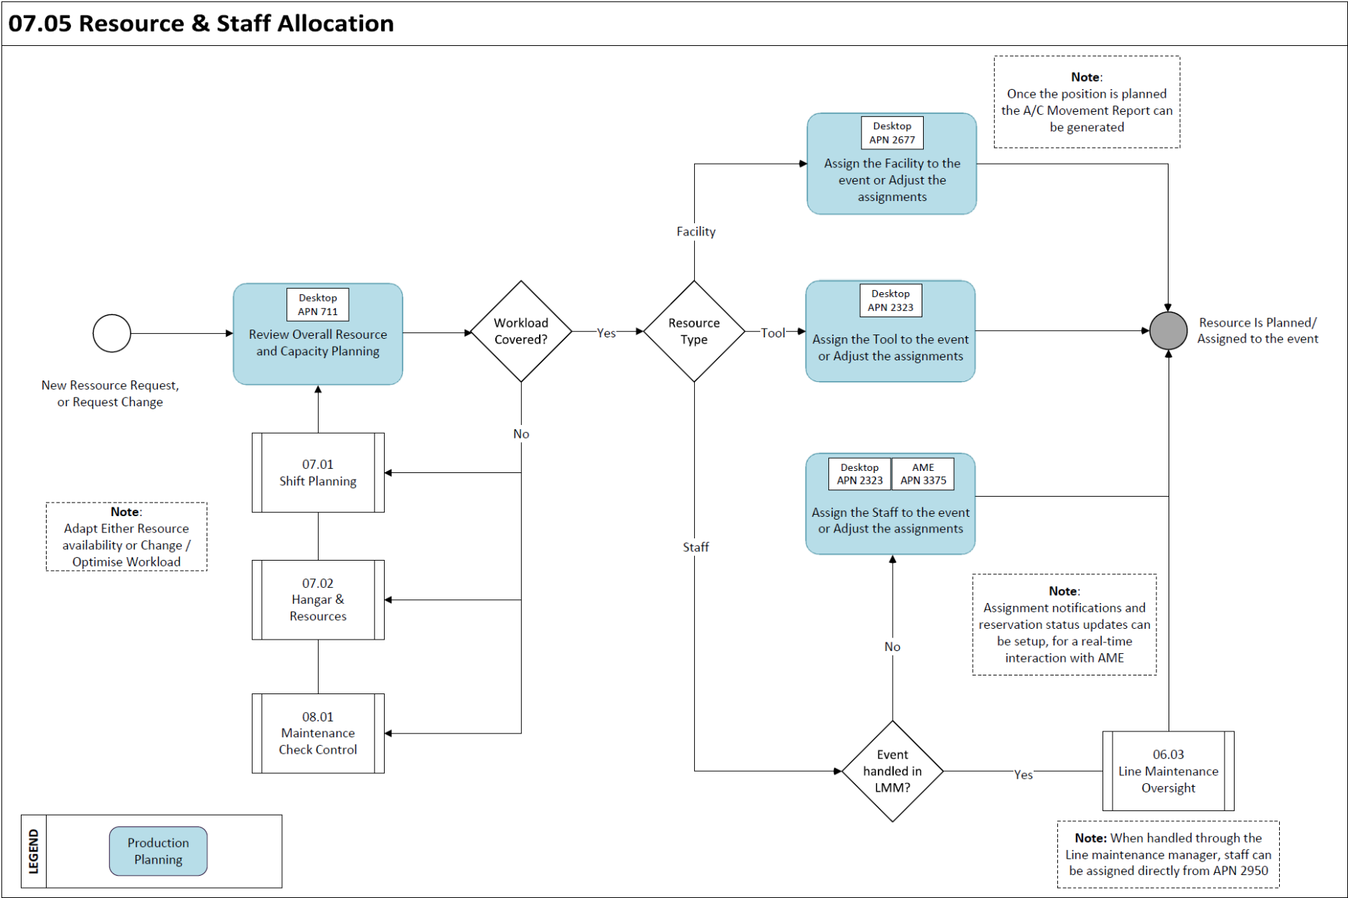

Process Design Questions

# | Question | Answer
1 | Which types of resources will be tracked within AMOS?
2 | Which department performs your resource planning for tools & equipment?
3 | Which department is responsible for Capacity Planning in terms of staff and hangar availability?
4 | Do you have maintenance facilities available? If so, are these only at the homebase or also outstations.
5 | Which tool do you currently use to perform the hangar plan?
6 | Do you perform maintenance for third parties?
7 | Do you manage the Shift Plan in AMOS?

Data (Source) Mapping

Data Sources | Description | Volume / Manual / Automatic / Static / Dynamic
Build plan or other | Top-down images of maintenance facilities | Static
Shift Plans | Refer to 07.01 Shift Planning | Semi-Static
Resource definitions | Refer to 07.02 Hangar & Resources. | Dynamic

Other Software Used

Other Softwares | Used by: | Description
-Nil-

AMOS Configuration

The 07.05 Resource & Staff allocation related APNs are heavily relying on the inputs of processes 07.01 Shift Planning and 07.02 Hangar & Resources. Furthermore, the process related APN’s can be extensively configured from within the respective APN.

Basic Data

Basic Data Table | Notes
Planning Qualifications | This table contains all the Skills and Scopes used through AMOS. An entry can be defined as Skill only, Scope only, or both, as Skill AND Scope.
Maintenance Calendar | This table stands to define a high-level representation of common shifts groups dedicated to the maintenance. The standard definition is a sequence of Early, Late and Night shifts.

Parameters

Parameter Code | Parameter Name | Notes
1809 | Planning Resource parameters | This parameter is related to the improvement of performances with the loading of resources in AMOS.
1885 | Maintenance Calendar Time Zone | Use this parameter to define the time-zone of the Maintenance Calendar Entries defined in the Program "Basic-Data Administration".

Workflows

Workflow Number | Workflow Name
378 | After creating, updating or deleting a Calendar Entry
379 | Before creating, updating or deleting a Calendar Entry
471 | Before creating, updating or deleting a Calendar Entry
472 | After creating, updating or deleting a Calendar Entry
460 | Work Assignment / De-assignment Notification
449 | Feedback Workflow for AMOS Notification in AMOSmobile

Scheduled Tasks

Scheduled Task Reference | Frequency | Notes
CapacityPlanningCalculationTask | daily
StaffReservationUpdateBasedOnShiftEndTask | 15 minutes | Buffer can be setup

API’s & Interfaces

Reference | Direction | Trigger | Frequency
TRANSFER BOOKING | IMPORT / EXPORT
TRANSFER STAFF ATTENDANCE | IMPORT
TRANSFER STAFF AVAILABILITY | IMPORT / EXPORT
TRANSFER SIGN | IMPORT / EXPORT

Annex – Additional Info

-Nil-

